Step1: Open and start the installation process of Vmware vCentre and click on next button.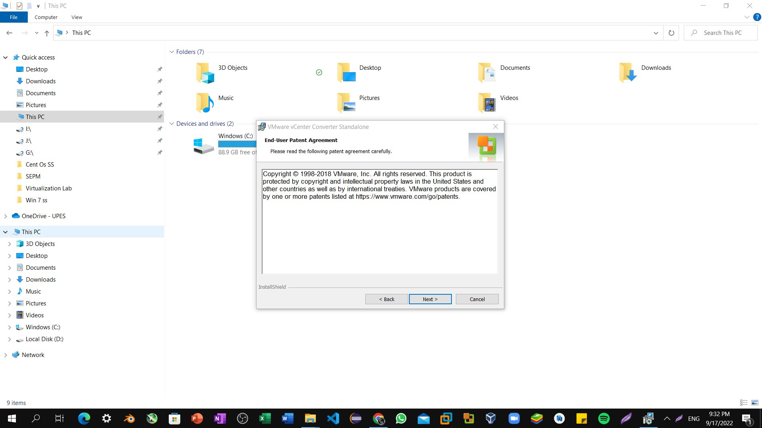

Step2: Click on I agree to terms in License Agreement.

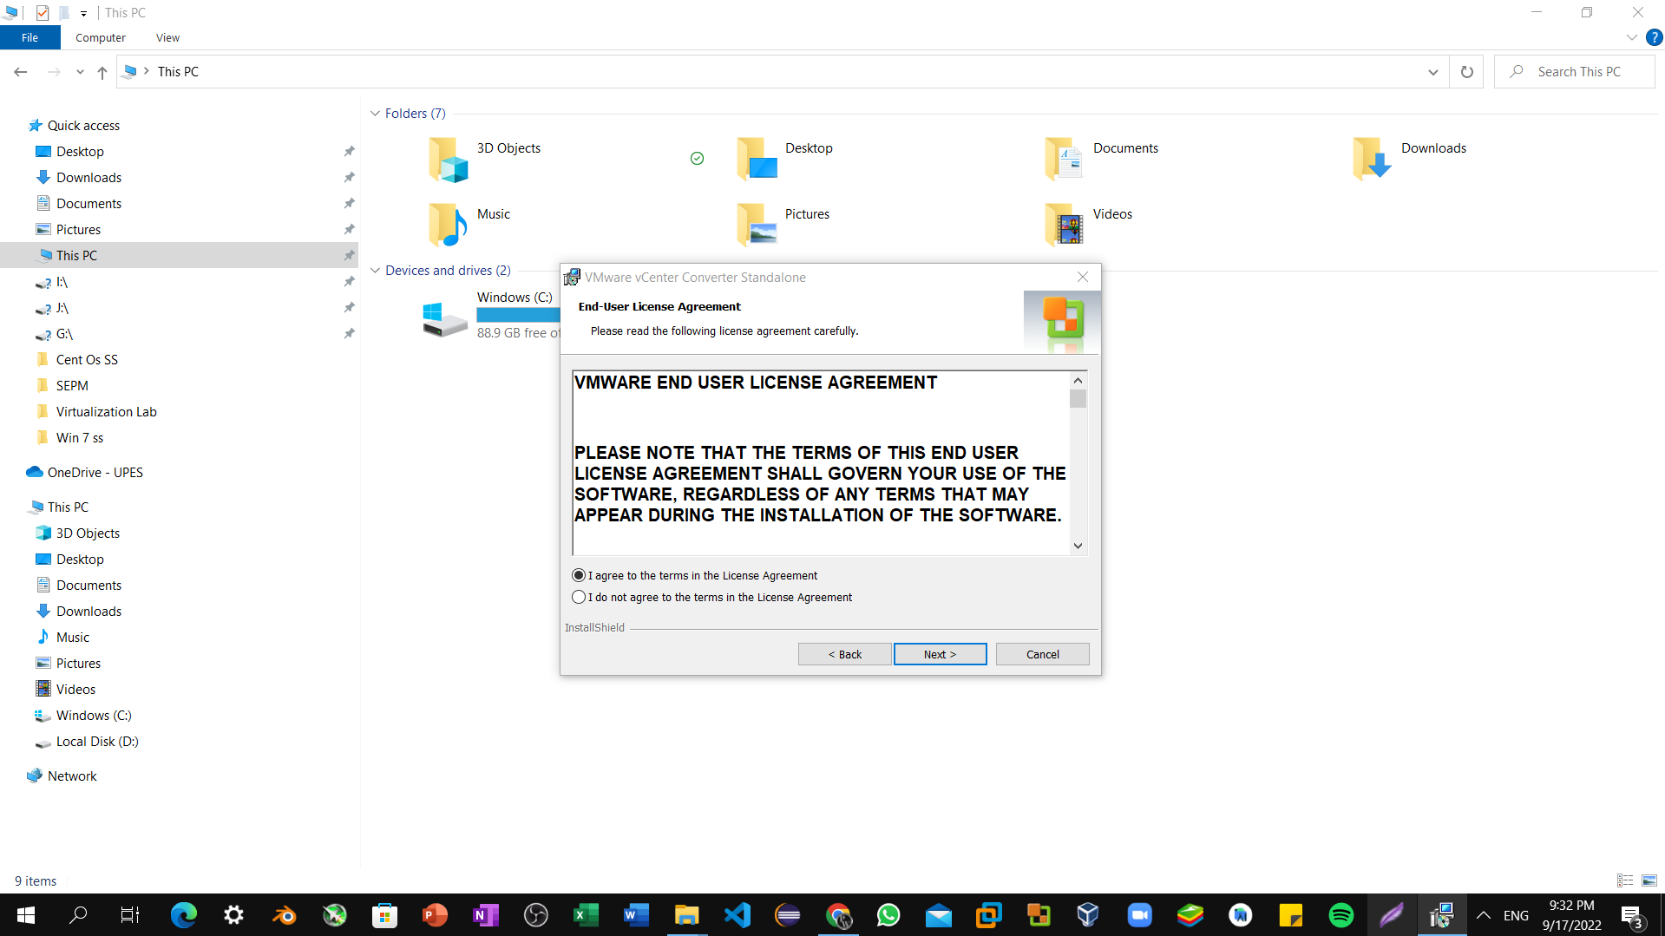

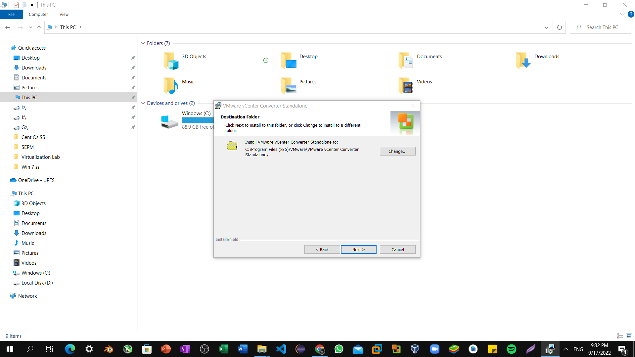Step3: Select Change button for changing installation path and click on next button.

Step4: Select C drive as path for installation and then click ok -> next.

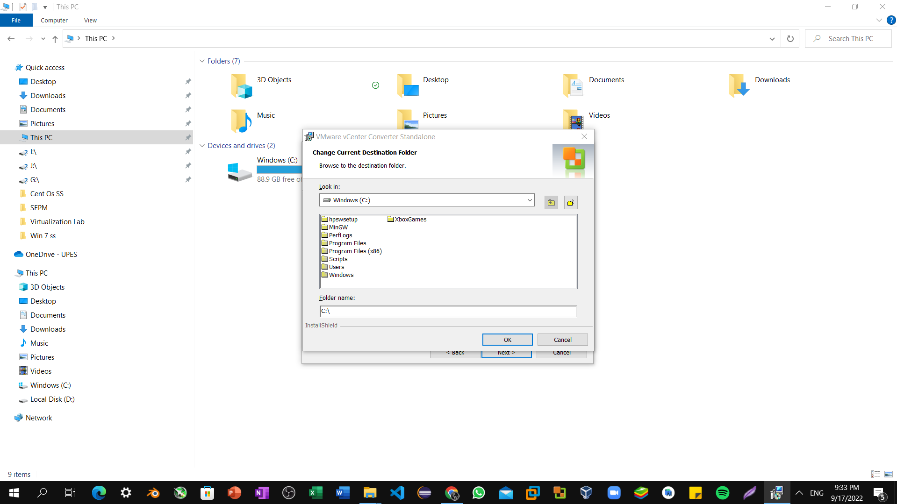

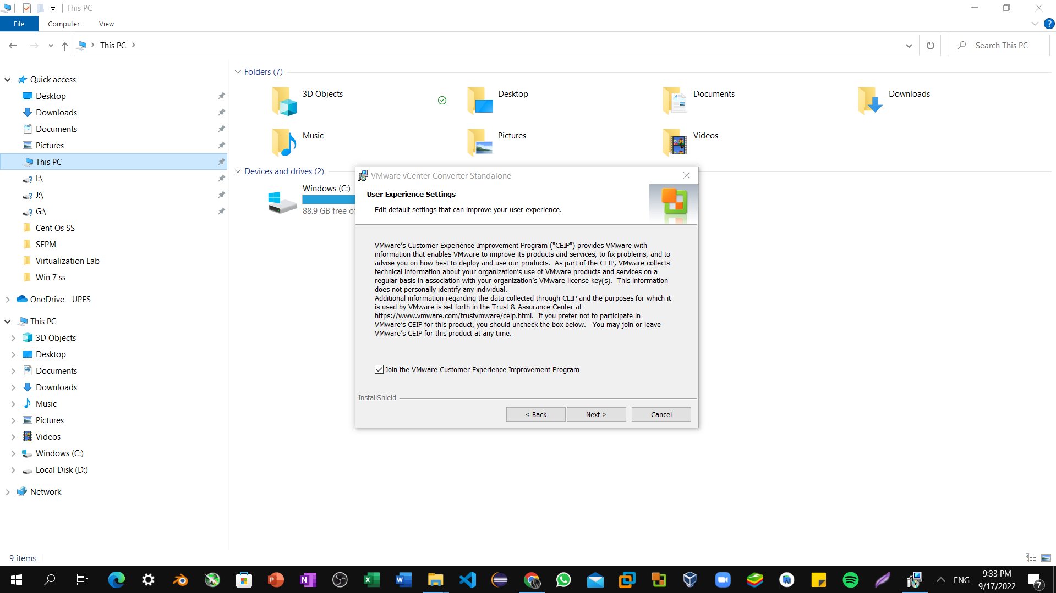Step5: Check Next Button and procced further.

Step6: Click on Install Button.

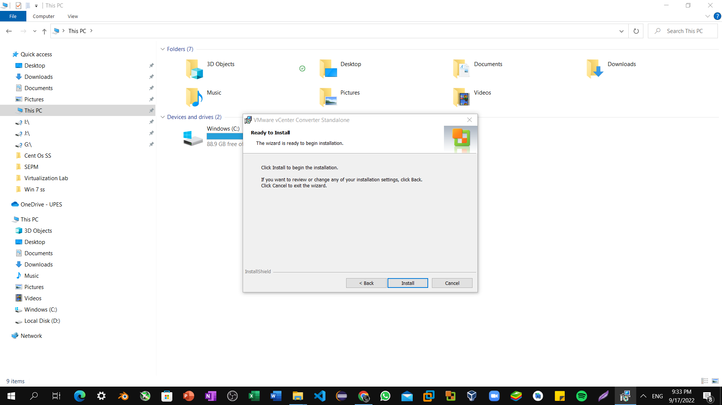

Step7: Wait till Installation being completed.

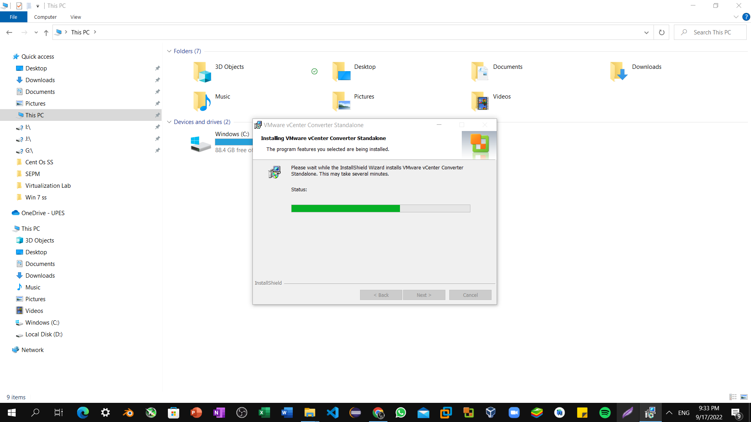

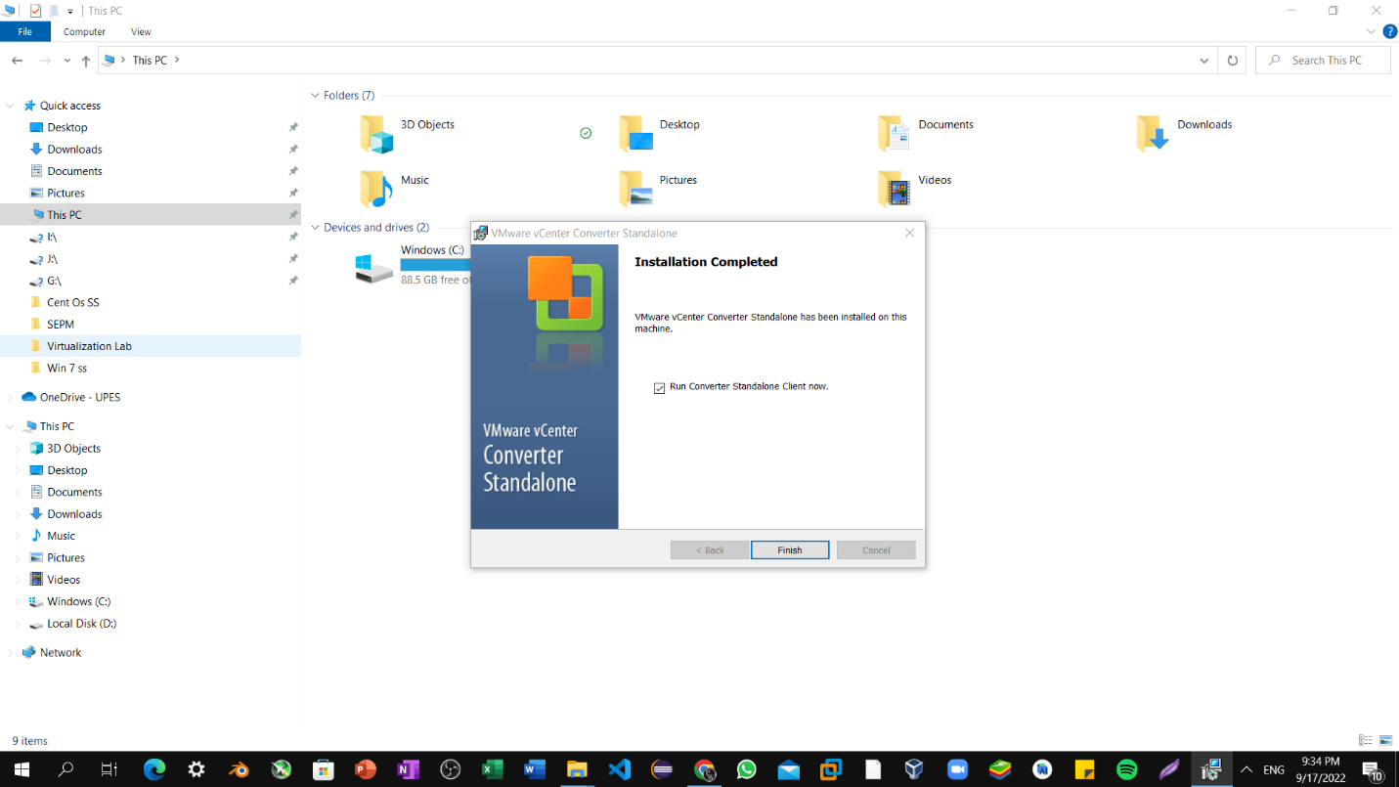Step8: Click on Finish Button and launch vCenter.

Step9: Click on Convert Machine and Proceed Further.

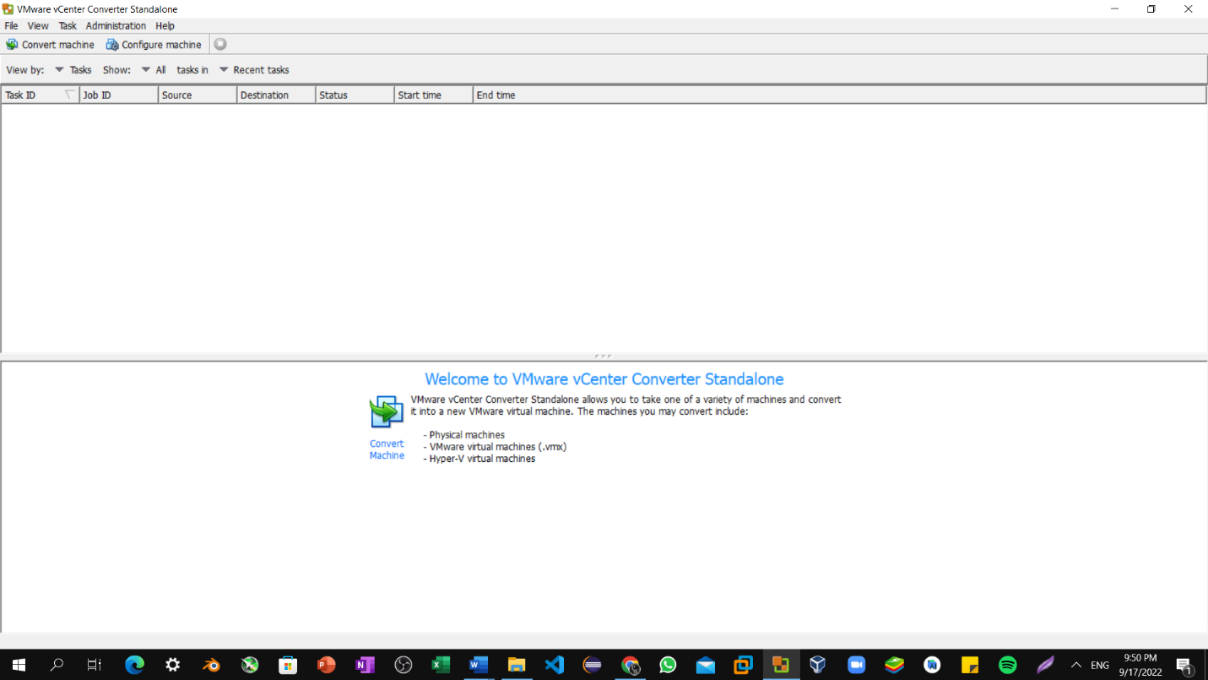

Step10: Click on Convert Machine and Proceed Further.

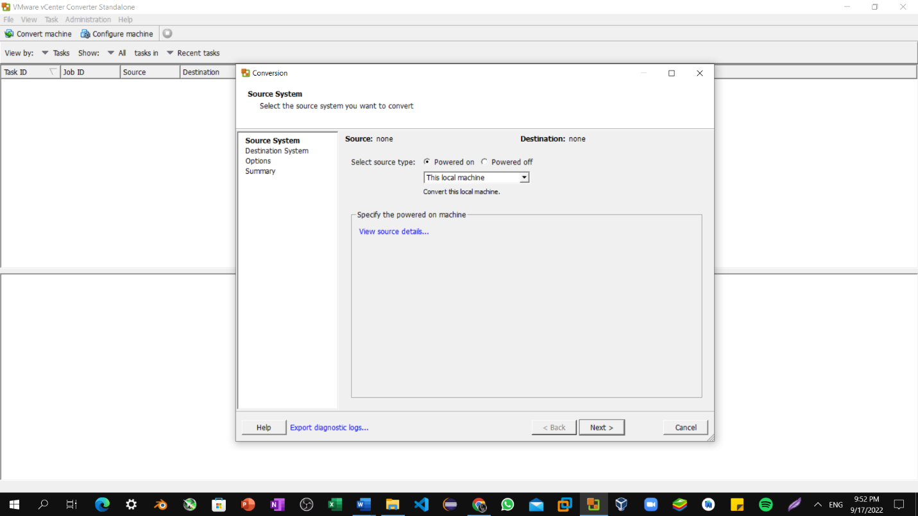

Step11: Select D Drive for creating virtual machine of current windows.

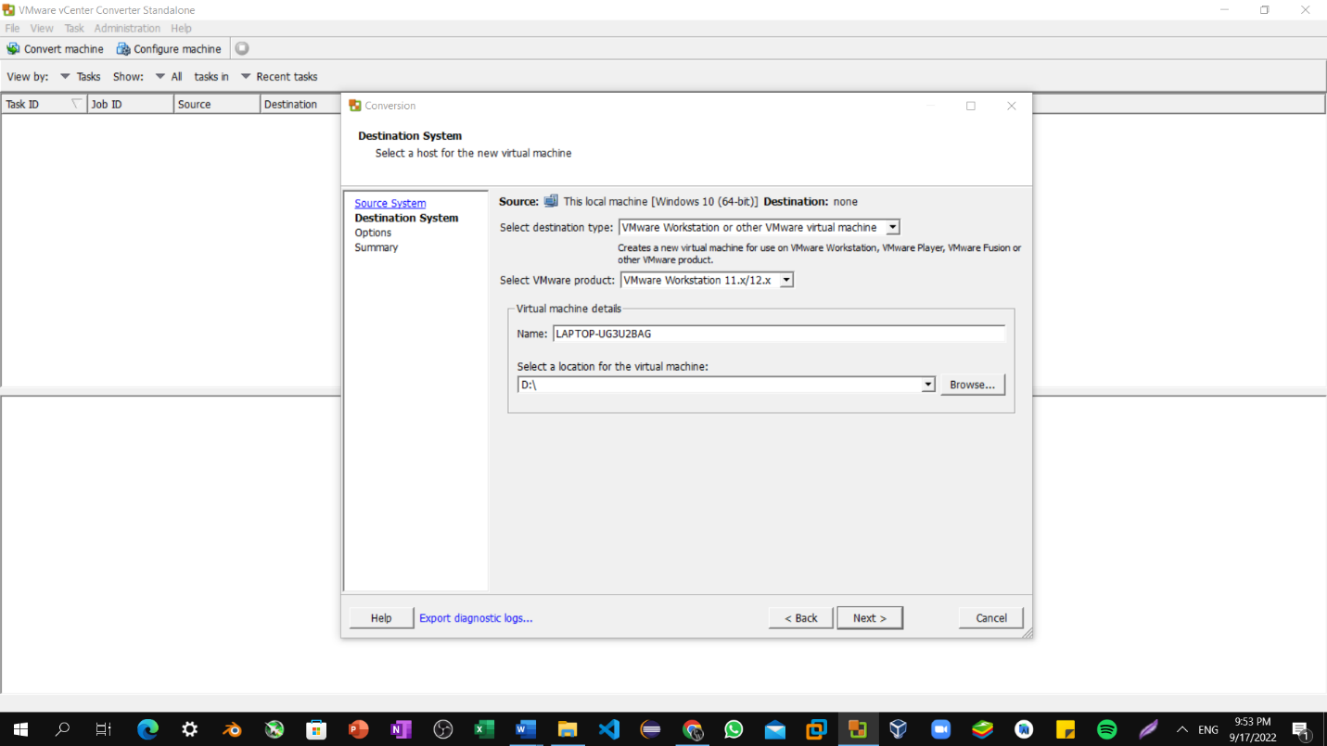

Step12: Then, go to edit section and uncheck C drive and then click on next button.

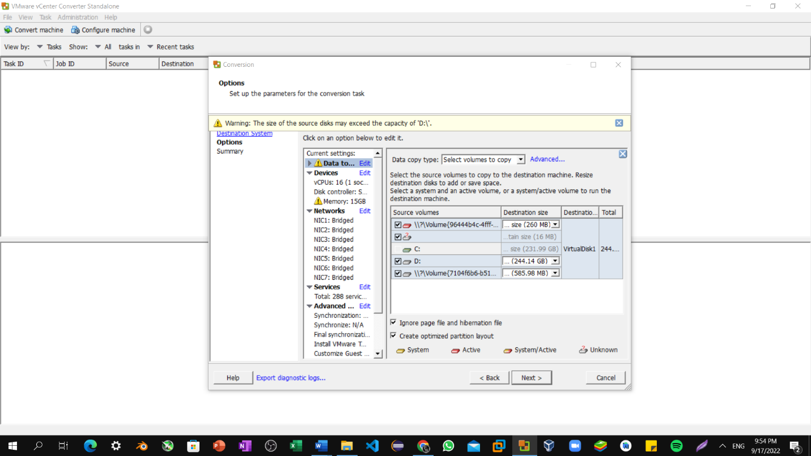

Step12: Progress bar of virtual machine creation.

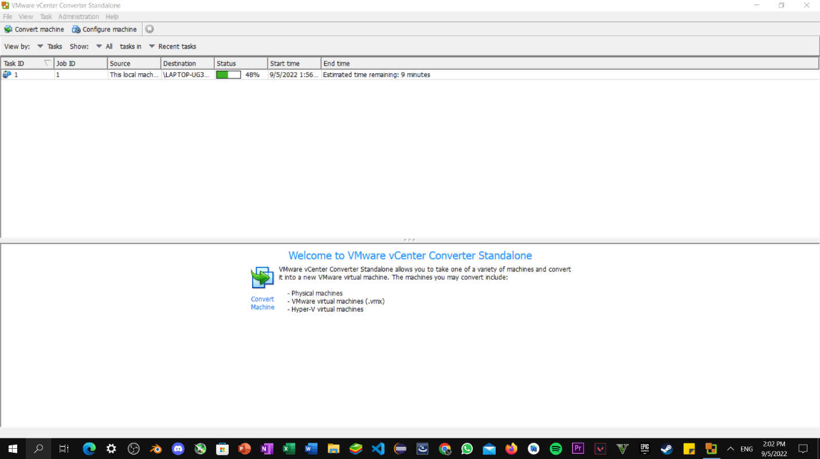

Step13: Virtual Machine successfully created.

